Day 4,5 LABS
Activity 1: Generate an Image through different tools using the same Prompt
Prompt:
Create a photorealistic image of a female airline customer-service executive standing at a modern international airport check-in counter. She is wearing a professional navy-blue uniform and looking directly at the camera. Soft natural light is entering from camera-left. The airport background is clean and modern, with passengers visible in soft focus. Use realistic skin texture, natural facial features, professional commercial photography, shallow depth of field and a 16:9 aspect ratio. Do not include any airline logo or readable text.

ChatGPT
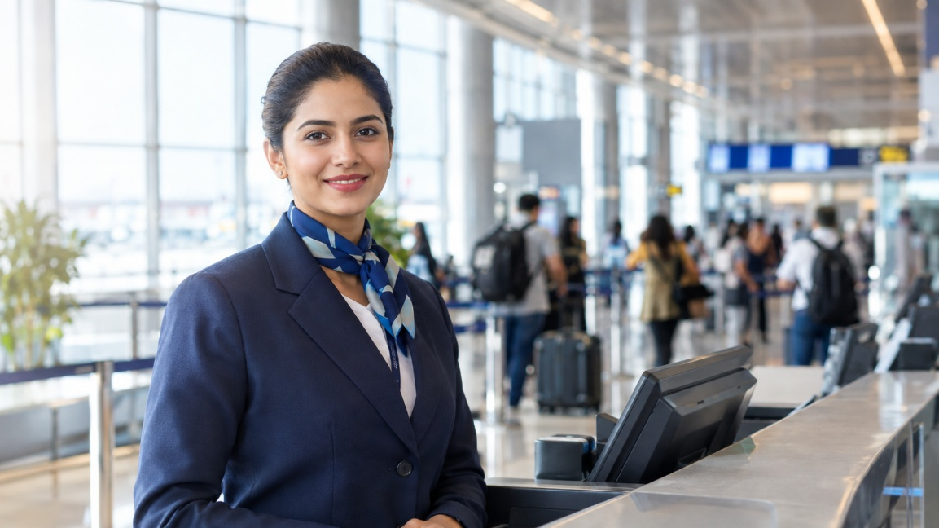

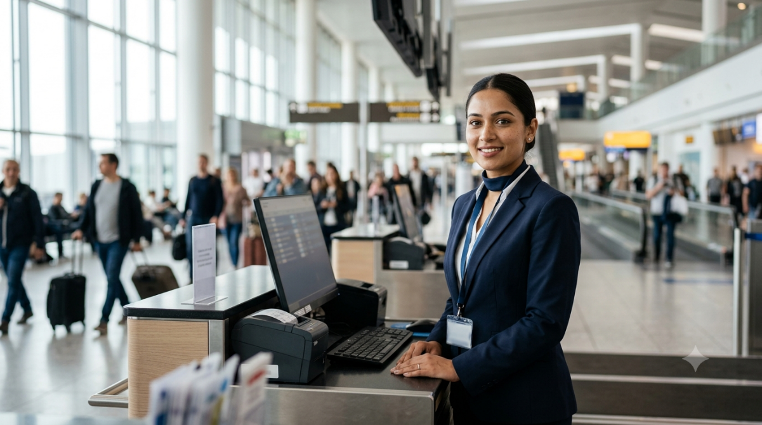
Gemini

Canva
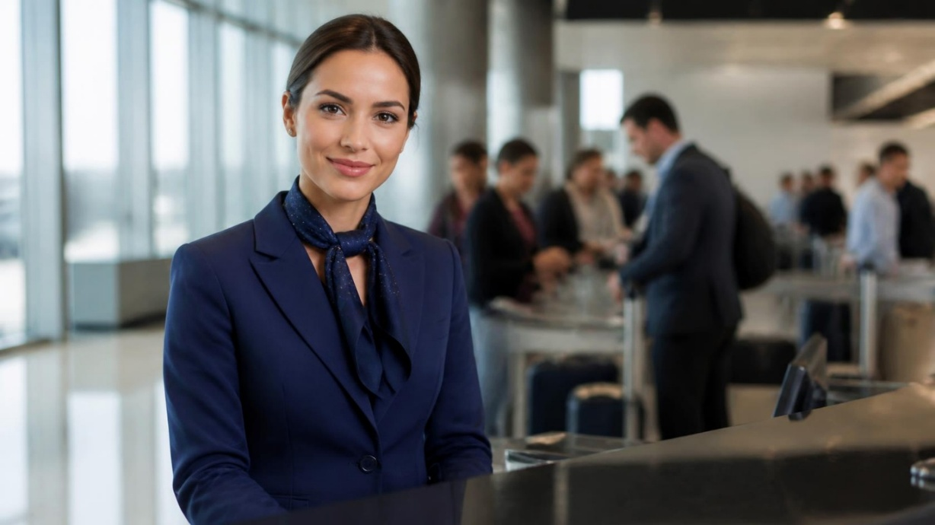

Activity 2: Observe the Model’s Visual Accent (Comparison)
Evaluation Criterion | Tool 1 – ChatGPT | Tool 2 – Gemini | Tool 3 – Canva
Name of AI tool | ChatGPT | Gemini | Canva
Prompt followed correctly? | Yes – Most requested elements are present. | Yes – Main requirements are followed. | Yes – Female airport executive, navy uniform and airport setting are present.
Human face appears realistic? | Yes – Natural facial features and proportions. | Yes – Realistic facial structure and expression. | Yes – Realistic face with natural features.
Skin texture appears natural? | Yes – Natural and detailed. | Yes – Realistic skin texture. | Yes – Smooth and realistic, although slightly polished.
Eyes and hands are correct? | Eyes: Yes. Hands: Not clearly visible. | Eyes: Yes. Hands: Mostly correct. | Eyes: Yes. Hands: Not clearly visible.
Airport environment is realistic? | Yes – Detailed modern airport and check-in area. | Yes – Detailed airport with passengers and equipment. | Yes – Realistic airport background with check-in counter and passengers.
Light comes from camera-left? | Yes – Soft light from the left. | Yes – Strong natural daylight from the left. | Yes – Natural daylight clearly enters from the left.
Uniform is professional? | Yes – Professional navy blazer and scarf. | Yes – Professional navy uniform with ID badge. | Yes – Professional navy blazer and scarf.
Unwanted text or logos present? | No obvious text or logos. | Minor issue – Some background signs/text-like details are visible. | No obvious airline logo or readable text.
Image looks AI-generated? Why? | Slightly – Very polished facial details and composition. | Slightly – Some background elements and a small visual artifact look AI-generated. | Slightly – Extremely smooth appearance and some background details appear artificially blurred.
Overall score out of 10 | 9/10 | 8/10 | 8.5/10

Analysis Questions

1. Which tool followed the prompt more accurately?
All three tools followed the main prompt quite well. ChatGPT closely matched the requested professional portrait style, while Gemini and Canva placed more emphasis on the airport environment and check-in setting.
2. Which image appeared more realistic?
The three images are realistic overall, but ChatGPT has the most polished commercial-photography appearance. Canva also looks realistic, particularly in the subject's face and uniform.
3. What differences did you observe in lighting?
ChatGPT uses soft and balanced lighting coming from the left side. Gemini has brighter natural daylight from the large windows, while Canva uses softer, slightly warmer-looking lighting with strong illumination from the left.
4. Did either image contain distorted eyes, hands or facial features?
None of the three images has obvious distortion in the eyes or major facial features. Gemini shows the hands more clearly and they appear generally natural, while the hands in ChatGPT and Canva are less visible.
5. Which image would you use on an airline’s website?
The ChatGPT image would be suitable for an airline website because it has a clean, professional corporate appearance and keeps attention on the customer-service executive. Canva would also work well for a professional airport-service campaign because of its realistic airport background.
6. What is the “visual accent” of each model?
ChatGPT: Premium, polished and corporate, with strong focus on the executive.
Gemini: Operational and environment-focused, showing more of the airport and check-in equipment.
Canva: Professional and promotional, with a strong emphasis on the executive and a softly blurred airport background.

Activity 3: Test Spatial Instructions

Prompt A — Camera-Left (ChatGPT)
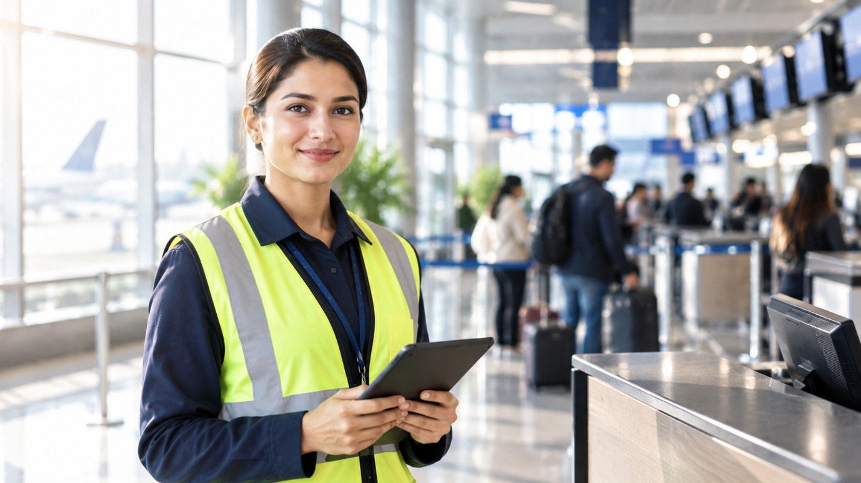
Create a photorealistic image of an airport ground-staff executive standing beside a check-in counter. Soft morning light must enter from camera-left and illuminate the left side of the image. The executive should hold a tablet. Include a modern airport background in soft focus. Professional photography, realistic facial features, 16:9 aspect ratio, no logos and no readable text.

Prompt B — Camera-Right (ChatGPT)
Create a photorealistic image of an airport ground-staff executive standing beside a check-in counter. Soft morning light must enter from camera-right and illuminate the right side of the image. The executive should hold a tablet. Include a modern airport background in soft focus. Professional photography, realistic facial features, 16:9 aspect ratio, no logos and no readable text.

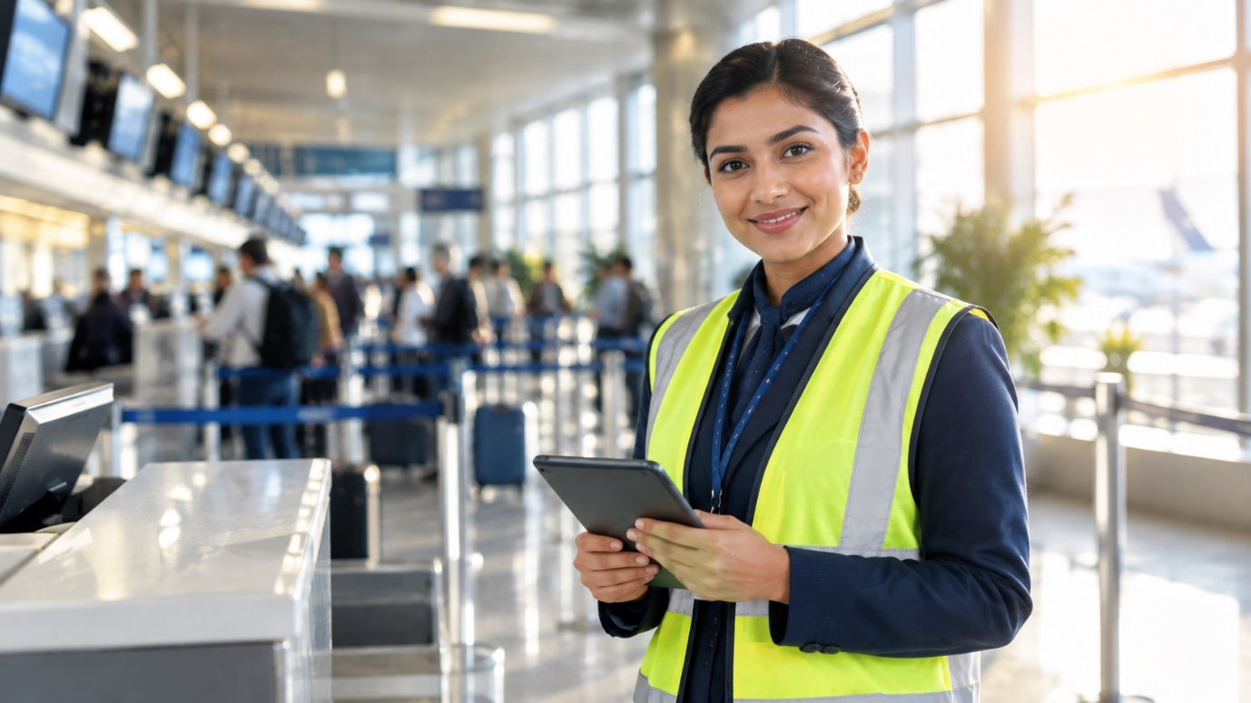

Record Your Observations
Question | Observation
Did the lighting direction change? | Yes. In the Camera-Left image, the strongest morning light comes from the left side of the image. In the Camera-Right image, the strongest light comes from the right side.
Was camera-left followed correctly? | Yes. The Camera-Left image shows bright window light entering from the viewer’s left, illuminating the left side of the scene and executive.
Was camera-right followed correctly? | Yes. The Camera-Right image shows strong daylight entering from the viewer’s right, illuminating the right side of the scene and executive.
Did the background remain consistent? | Mostly yes. Both images show a modern airport, check-in counters, passengers, queue barriers and a softly blurred background, although the exact arrangement and perspective changed.
Did the person’s appearance change? | Yes. The person changed between generations, including facial features, hairstyle and positioning, although both remained professional airport ground staff wearing similar navy uniforms and reflective vests.
Which instruction was ignored, if any? | No major instruction was ignored. Both images followed the requested lighting direction, tablet, airport setting, professional photography and 16:9 composition. Some background screens contain visual details, but no clearly readable text or logos are visible.

Learning Point
Using camera-left and camera-right made the lighting instruction much clearer. The comparison shows that the model was able to change the light direction while keeping the main airport scene and subject concept broadly consistent.

